GOLDEN LOTUS RESONANCE FACIAL
Radiance · Lift · Nervous System Reset

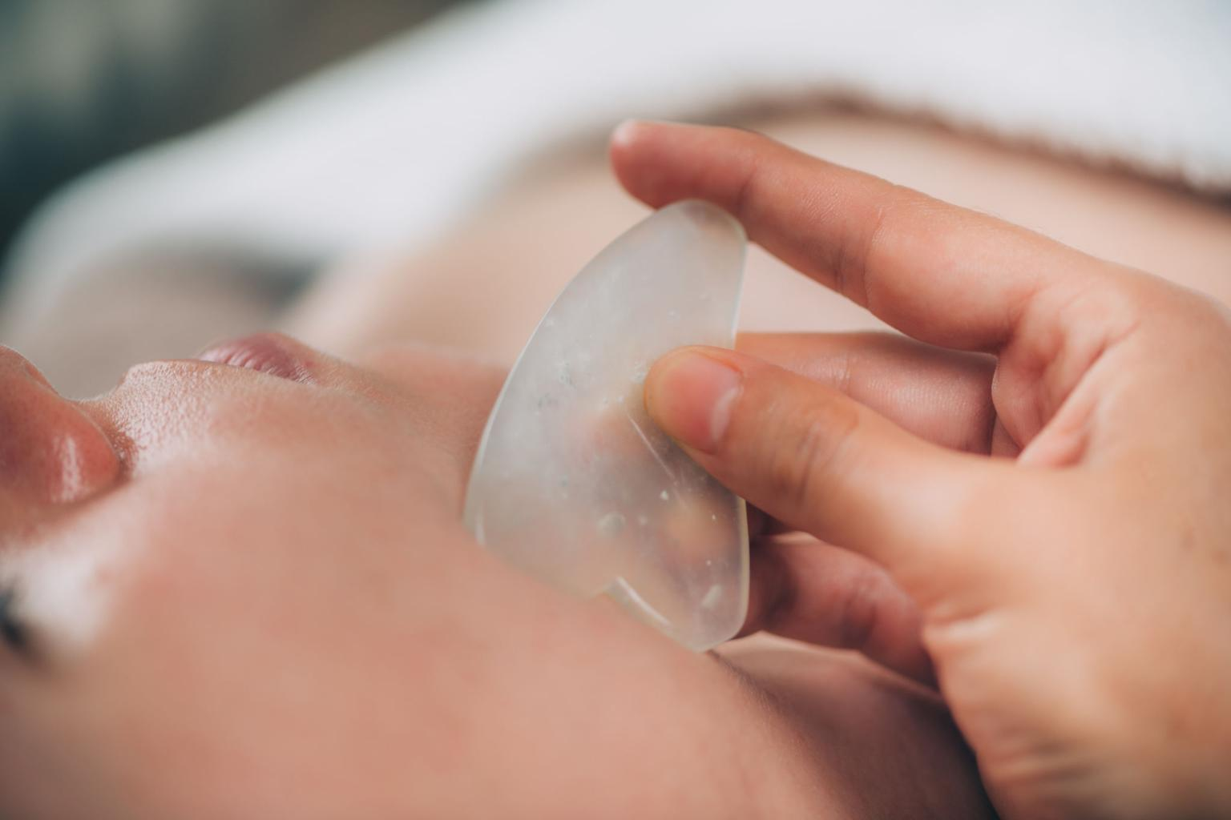
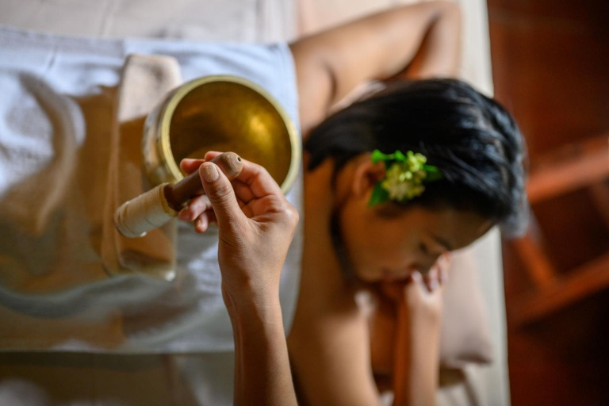

This ritual focuses on structure, tone, and expression.
The face is treated as a network of muscles and fascia that hold emotional and mechanical tension. Before any sculpting begins, vibration is used to soften micro-contractions in the jaw, forehead, and cheek area, allowing the tissues to respond more effectively to manual work.
Sculpting techniques inspired by both gua sha and Thai rhythmic touch are then applied to lift, drain, and reorganize the face. The movements are slow, precise, and repetitive, creating both a visible lifting effect and a deep neurological relaxation.
Ingredients are chosen to support glow and regeneration:
— Rice bran oil (light, antioxidant, traditional in Asia)
— Coconut-derived cleansers (gentle, barrier-respecting)
— Papaya or pineapple enzymes (natural resurfacing)
— Centella asiatica (repair and collagen support)
— Aloe vera (hydration and calming)
— Optional gold-infused serum (radiance and luxury finish)
The skin is not forced into activation. It is guided into responsiveness.
75 min — 125€
90 min — 155€

TROPICAL MOON REJUVENATION FACIAL
Drain · Soothe · Rebalance

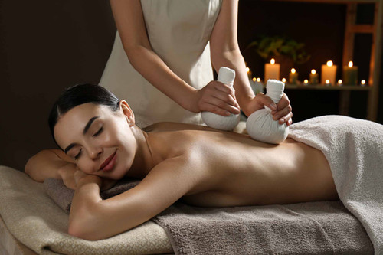
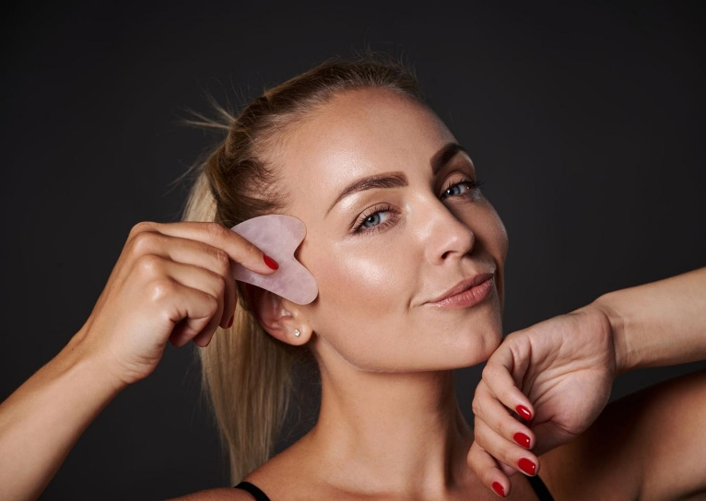

This ritual focuses on fluid, inflammation, and sensitivity.
When the face feels heavy, swollen, or reactive, the priority is not stimulation but drainage and cooling. This treatment uses slow, rhythmic lymphatic techniques to move excess fluid and reduce stagnation, particularly around the jaw, eyes, and neck.
Herbal compresses are applied to gently open circulation without overheating the skin, followed by cooling applications that calm and rebalance.
Vibration is introduced in higher, lighter frequencies to help the system down-regulate and release internal tension without intensity.
Ingredients are selected for their cooling and anti-inflammatory properties:
— Aloe vera (deep hydration and soothing)
— Cucumber extract (cooling and decongesting)
— Centella asiatica (repair and skin resilience)
— Rose water (gentle toning and calming)
— Lemongrass and pandan (circulation + sensory reset)
— Turmeric in micro-dose (anti-inflammatory, glow support)
The face becomes lighter, clearer, and more defined — without force.
60 min — 75€
75 min — 105€

THAI FLOW VIBRATIONAL RITUAL (OIL-FREE)
Rhythm · Stretch · Release
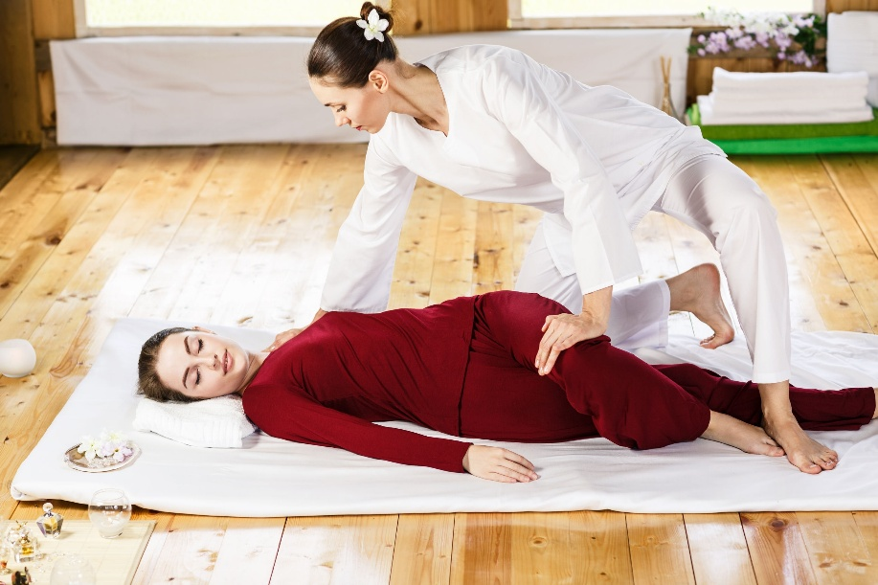
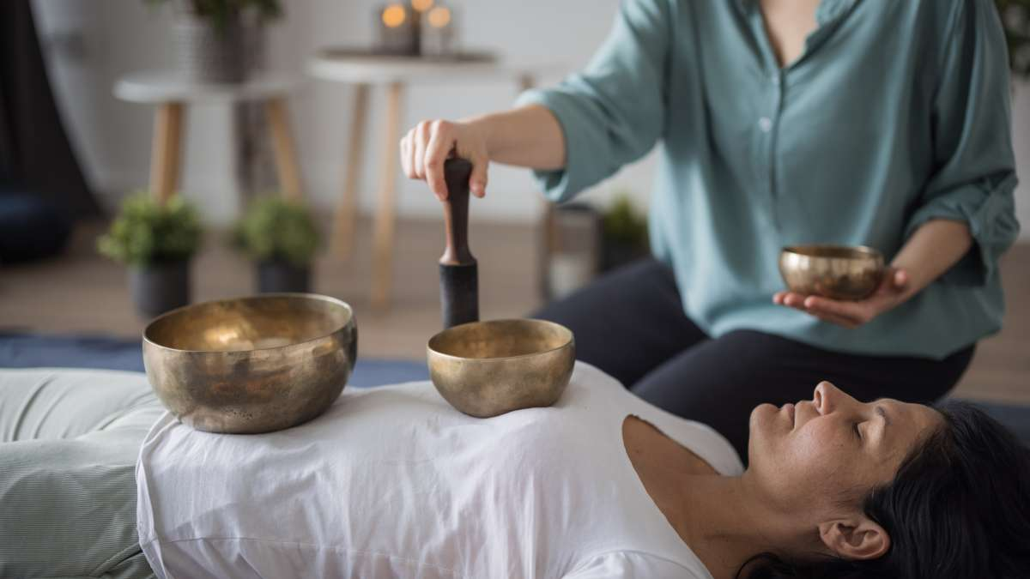
This ritual works on movement, space, and internal rhythm.
Performed fully clothed and without oil, the body is guided through sequences of pressure, assisted stretches, and continuous transitions. The work follows the Sen lines (energy pathways in Thai tradition), releasing areas of stagnation while restoring natural mobility.
The absence of oil allows for deeper precision, traction, and joint work. The body is not only massaged — it is moved, opened, and reorganized.
Sound is applied directly onto the body using bowls and tuning forks, accelerating muscular release and creating a state where the mind disengages and the body becomes more receptive.
There is no single technique. The treatment adapts moment by moment to the response of the tissues.
No cosmetic ingredients are used in this ritual. Instead, the “active elements” are:
— Pressure (acupressure and body weight)
— Stretch (assisted, progressive opening)
— Rhythm (continuous, wave-like sequencing)
— Vibration (deep tissue resonance)
The result is a body that feels longer, lighter, and structurally reset.
60 min — 95 €
90 min — 125€

SIGNATURE PHILOSOPHY
In these rituals, products support the work — they do not replace it.
The transformation comes from the combination of skilled touch, precise rhythm, and vibrational intelligence.
This is where visible beauty and internal regulation meet.

